**High level Design (HLD)**

**Google App store Dataset Analysis**

Revision Number: 1.0

Last date of revision: 17/09/2023

Mangesh Yadav

**Document Version Control**

|  |  |  |  |
| --- | --- | --- | --- |
| **Date Issued** | **Version** | **Description** | **Author** |
| **17th Sep 2022** | 1.0 | First Version of Complete HLD | Mangesh Yadav |
|  |  |  |  |
|  |  |  |  |
|  |  |  |  |
|  |  |  |  |
|  |  |  |  |
|  |  |  |  |

[AUTHOR NAME]

# Contents

High level Design (HLD) 1

Contents 3

1. Introduction 4
   1. Why this is a high level document(HLD) 4
   2. Scope 4
2. Genral Description 5
   1. Problem statement 5
   2. Tools used 5
3. Design details 5
   1. Functional architecture 5
   2. Optimization 6
4. KPI 6
   1. KPIs Key performance indicator 6

5 Deployment 9

# 1 Introduction

**1.1 Why this High-Level Design Document?**

The purpose of this High-Level Design (HLD) document is to add the necessary detail to the current project description to represent a suitable model for coding. This document is also intended to help detect contradictions before coding and can be used as a reference manual for how the modules interact at a high level.

The HLD will:

* Present all of the design aspects and define them in detail
* Describe the user interface being implemented
* Describe the hardware and software interfaces
* Describe the performance requirements
* Include design features and the architecture of the project
* List and describe the non-functional attributes like: o Security o Reliability o Maintainability o Portability o Reusability

o Application compatibility o Resource utilization o Serviceability

**1.2 Scope**

The HLD documentation presents the structure of the system, such as the database architecture, application architecture (layers), application flow (Navigation), and technology architecture. The HLD uses non-technical to mildly-technical terms which should be understandable to the administrators of the system.

# 2 Genral Description

## 2.1 Problem statement

Technology is the increasing need nowadays and used everywhere. One of the features of technology is Android. Which we all use in our daily life. Android is a mobile operating system based on modified version of linux kernel and other open source software, designed primarily for touchscreen mobile devices such as smartphones and tablets.

## 2.2 Tools used

Business intelligence tools and libraries work such as Python, Numpy, Pandas, Matplotlib, and Excel used to build the whole framework.

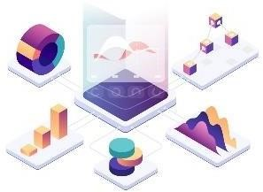

# 3 Design Details

## 3.1 Functional Architecture

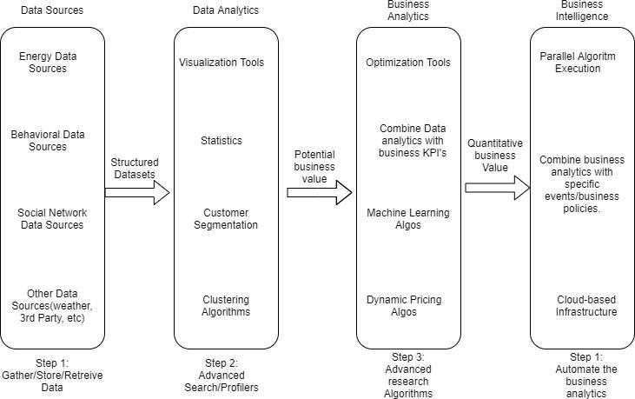

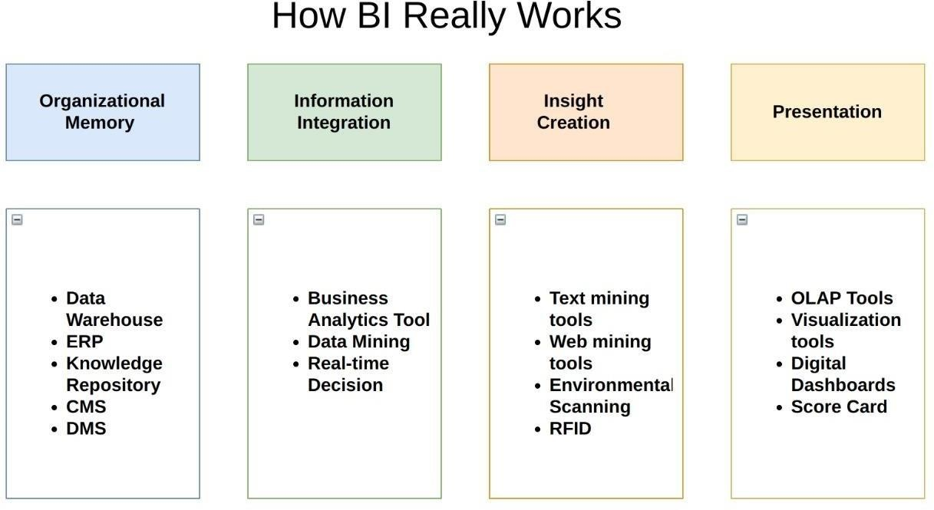

## 3.2 Optimization

**Data strategy drives performance**

* Minimize the number of fields
* Minimize the number of records
* Optimize extracts to speed up future queries by materializing calculations, removing columns and the use of accelerated views

**Reduce the marks (data points) in your view**

* Practice guided analytics. There’s no need to fit everything you plan to show in a single view. Compile related views and connect them with action filters to travel from overview to highlygranular views at the speed of thought.
* Remove unneeded dimensions from the detail shelf.
* Explore. Try displaying your data in different types of views.

# 4 KPI

KPI stands for key performance indicator, a quantifable measure of performance over time for a specific objective. KPIs provide targets for teams to shoot for, milestones to gauge progress, and insights that help people across the organization make better decisions. From finance and HR to marketing and sales, key performance indicators help every area of business move forward at strategic level.

## 4.1 KPIs (Key Performance Indicators)

Key Indicators displaying a summary of the Google play store data and its relationship with different metrics.

* Communication and social have more reviews among all category

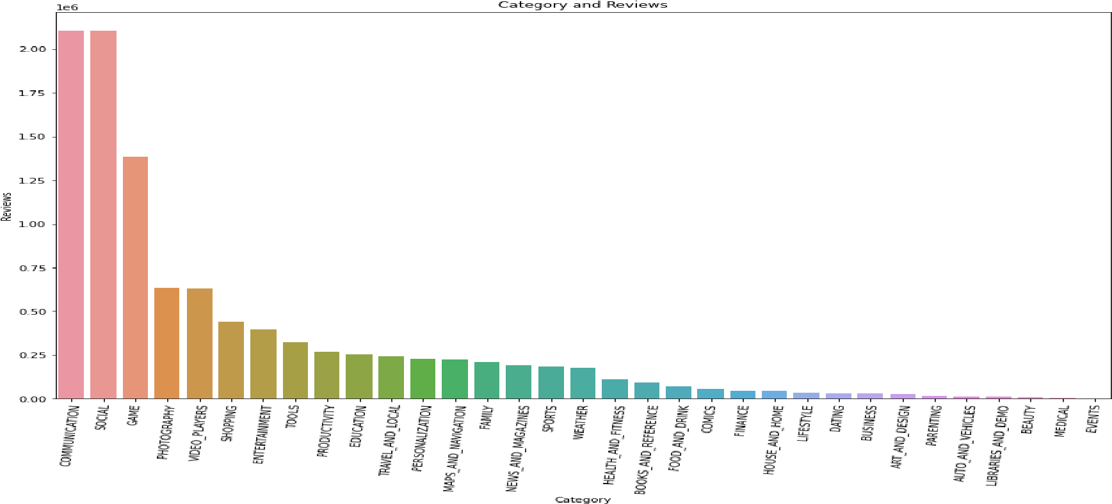

* Communication category apps has highest Installs followed by Social and Medical has least installs among the category.

Tools

genres

has

the

highest

number

of

apps

among

all.

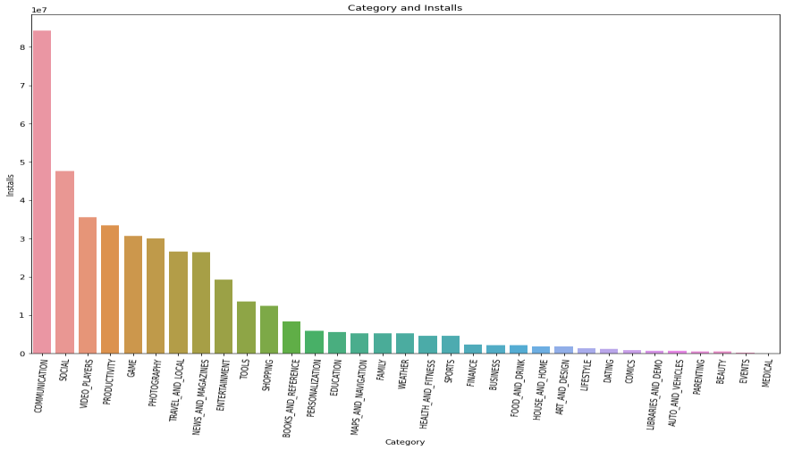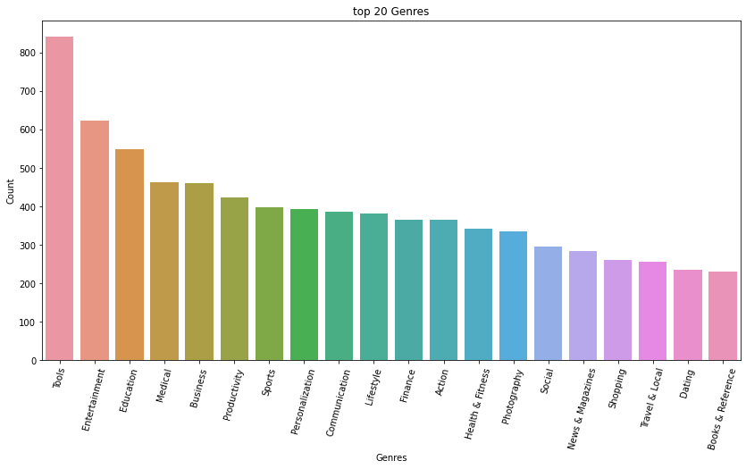

•

* Communication genres has the highest number of installs among the category.

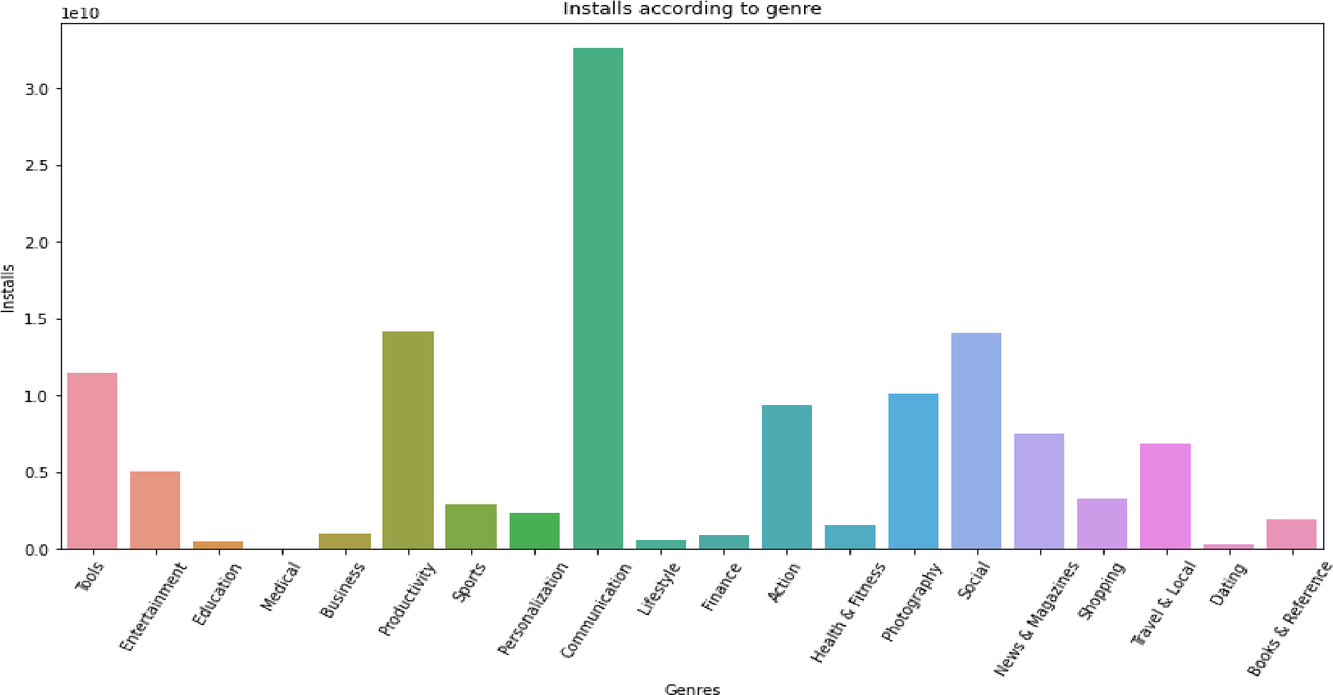

* Family category has the most number of free and paid apps followed by games category.

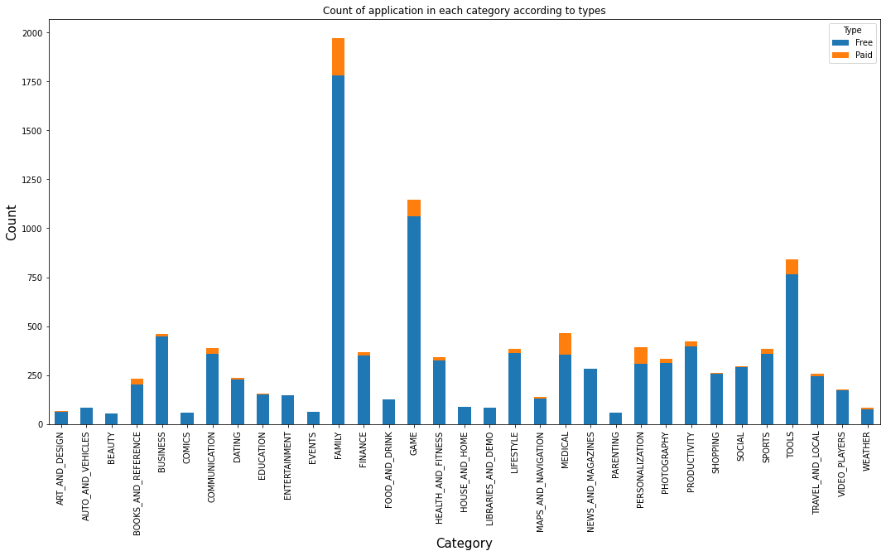

* Most number of apps are more than 5MB of size.

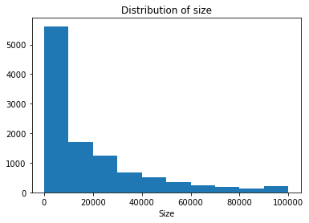

* Game category has the most number of Positive, Negative and Neutral reviews.

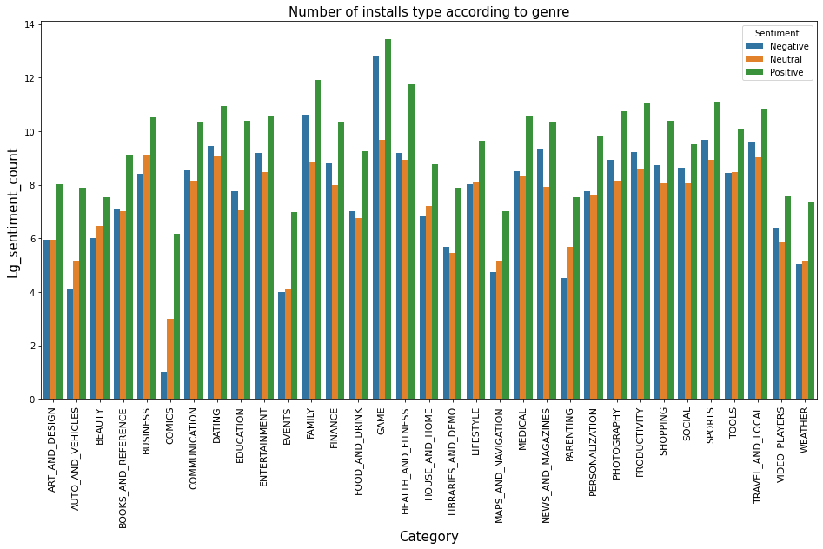

## **5 Deployment**

Prioritizing data and analytics couldn’t come at a better time. No matter what size, your company is already collecting data and most likely analyzing just a portion of it to solve business problems, gain competitive advantages, and drive enterprise transformation. With the explosive growth of enterprise data, database technologies, and the high demand for analytical skills, today’s most effective IT organizations have shifted their focus to enabling self-service by deploying and operating various Business Intelligence tools.